exceed two pages (eac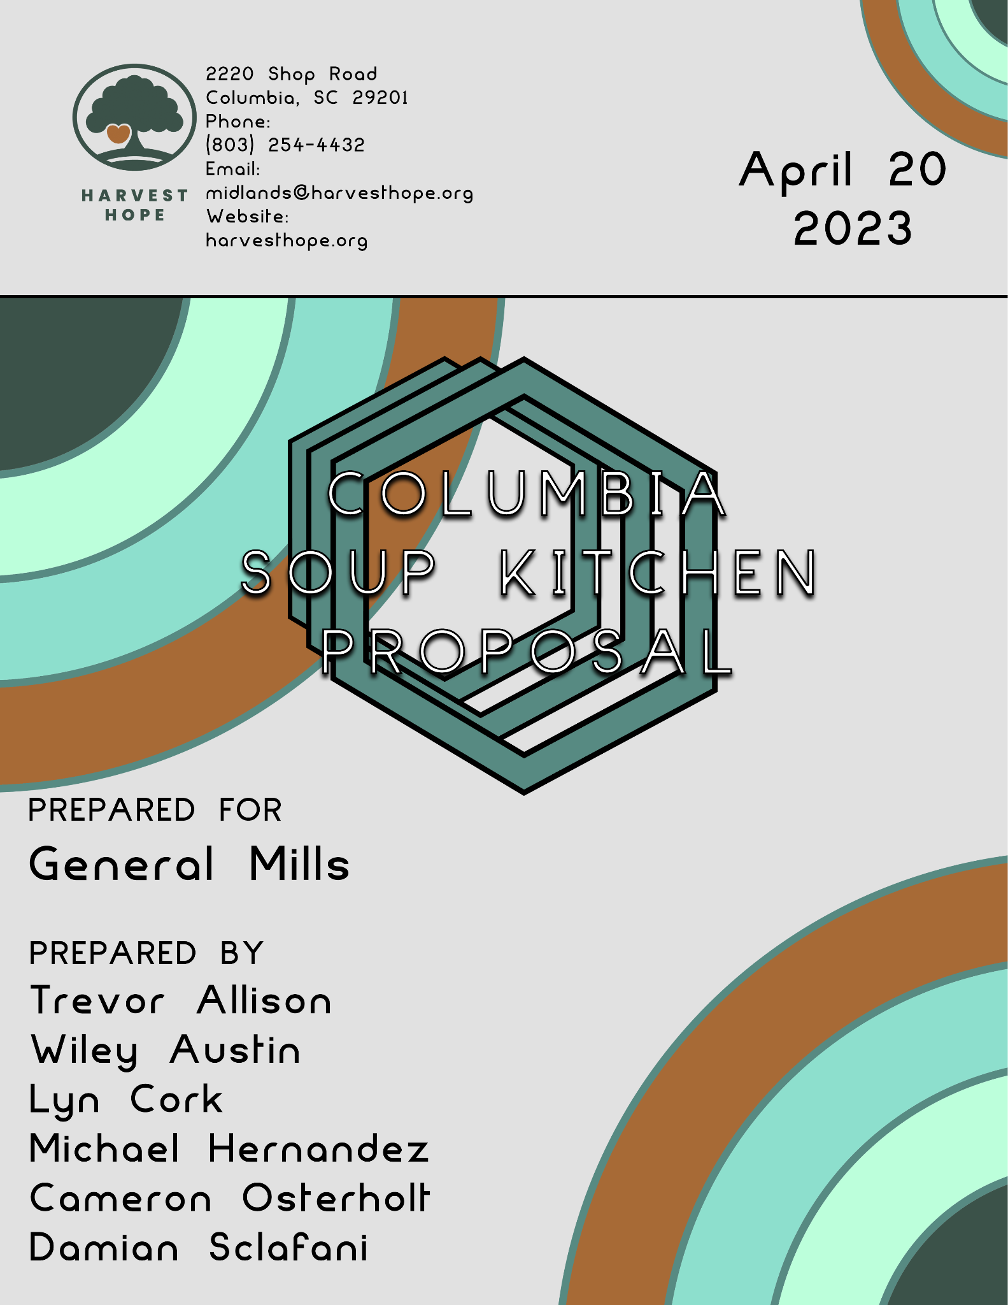

**Introduction**

Harvest Hope South Carolina would like to present to you a new final opportunity. Our nonprofit organization is asking General Mills for $27,500. Our project is a week-long soup kitchen in Downtown Columbia, South Carolina with the intent to provide food for children in need once the school year is over and free or reduced lunch is no longer an option. With your partnership, we intend to run a soup kitchen during the week of May 21st, 2023, and give containers of food to anyone that stops by. General Mills would get plenty of advertising during this event because of the banners hung up and the merchandise provided to anyone that stops by. Furthermore, we intend to have volunteers working at this event, which will prove helpful to any students in need of service hours and will reduce the overall cost of the event. Along with that, we intend to hold a private fundraiser event following the soup kitchen. Funding for this project would provide thousands of children with food and give GM plenty of advertising.

**Problem Statement**

Harvest Hope began in 1981 with the intent to provide for the hungry in Columbia. Since then, Harvest Hope has expanded to 20 counties in South Carolina. Our mission is to eliminate hunger and food insecurity throughout South Carolina by distributing food to pantries, shelters, and soup kitchens.

South Carolina is at the forefront of this hunger and food insecurity in the United States. According to the Friends Committee on National Legislation (FNCL), we are the 9th poorest state, with a 14.1% poverty rate. Since we have this high poverty rate we are also the 8th hungriest state, with 12.6% of households experiencing food insecurity. Food insecurity, according to the USDA, is “a lack of consistent access to enough food for every person in a household to live an active, healthy life.” In South Carolina, 489,510 people are facing hunger. 153,330 of those 489,510 people facing hunger are children. So that means in South Carolina, 1 in 10 people face hunger and 1 in 7 children face hunger.

To combat this hunger and food insecurity in children, school districts in South Carolina provide meals to the underprivileged. According to the South Carolina Department of Education, “Students from households with qualifying income may receive their lunches free or at a reduced price of $0.40.” According to Feeding America, “Children in households with incomes below 130 percent of the poverty level or those receiving Supplemental Nutrition Assistance Program (SNAP) or Temporary Assistance for Needy Families (TANF) qualify for free meals.” To qualify for the $0.40 meals the incomes of the families must fall “between 130 and 185 percent of the poverty line.” In South Carolina, 48.3% of households receiving SNAP benefits have children, so many can qualify for free meals throughout the school year. Once summer hits a majority of households in South Carolina can lose access to these free meals.

In May of 2022, we received 1,000 new clients in South Carolina because school was out for the summer. This is because low-income families who were reaping the benefits from free or reduced meals for their kids no longer had this option for the summer. The average cost of a meal in South Carolina, according to Feeding America, is $3.09. This is much more than a $0.40 meal or a free meal for kids in school.

We at Harvest Hope seek your support. We ask that General Mills sponsor our soup kitchen and fundraiser from Sunday, May 21st to Saturday, May 27th. Funding for our soup kitchen is so vital because May is the time to combat child hunger in South Carolina. This is because the week we will have our Soup Kitchen is simultaneous with when schools in Columbia, South Carolina release for summer. We are requesting $27,500 for our event. $11,500 would go towards the total rent for the building. We will have to rent the kitchen at a rate of $95 an hour from 8:30 am - 6:30 pm each day we run. Lastly, we request $50 for flyers to promote the event so that volunteers and those in need know about it. Your logo will be on the flyers and on posters in the soup kitchen to give publicity to your company, but most importantly your money would help feed thousands of hungry children in Columbia, South Carolina.

**Project Plan**

Setup Overview

We will first reach out to the venue, Junction 800, to secure the location for the week of Sunday, May 21st - Saturday, May 27th, 2023.

Once reserved we will fill out the Event Facility Rental Agreement. It includes:

* + The names of the venue owner and the renter
  + The address of the venue
  + The start time and date and end time and date of the rental
  + The rental deposit amount, and when it is due
  + Provisions for a security deposit, if relevant
  + When final payment is due
  + Consequences for late payment
  + Any other terms or expectations

Security deposit will be due immediately at the time of reservation so we will transfer $3,000.

The necessary city permits to serve food will be completed at this time.

We will reach out to the following providers:

* DER Kitchen, a commercial Kitchen rental company, will be rented to provide the space to make the food
* Party Reflections, a party supplies company, will be providing the tables, chairs, and other supplies necessary for the main fundraiser event
* Food Lion, grocer to purchase and supply the food at the event
* Dee’s Wings, restaurant to purchase catering for the main fundraiser event

Create graphics to advertise the event. These will be printed and spread around Columbia and posted on Harvest Hope and General Mills’ social media accounts and websites.

We will reach out to USC’s Leadership and Service Center to generate student volunteer interest.

Kitchen Event

We will host a soup kitchen with hot food and canned food from Monday, May 22nd - Friday, May 26th.

Kitchen staff will be serving from 8:30 am - 6:30 pm each day.

Tables and chairs will be available for patrons to use for the duration of the opening hours.

We will be taking donations from locals outside the venue to help continue to fund Harvest Hope’s work.

Fundraiser Event

We will host an event on Saturday from 12:00 pm to 5:30 pm to bring the local community in to help donate.

5:30 pm - 7:30 pm will clean the space and prepare for a private catered dinner with prominent community members to encourage larger donations.

Decorations will be provided by Party Reflections.

Food will be provided by a local restaurant: Dee’s Wings.

Event will wrap up around 9:30 pm, and volunteers will complete the final cleanup.

**Project Outcomes**

The goal of this project is to not only increase the physical footprint of Harvest Hope but to expand our reach into the local community as well. Even though this event is only temporary, the impact on the local Columbia community and the publicity this will bring, allowing us to feed more people, will last a lifetime.

The primary outcome of this project is to provide food for children and families who are facing food insecurity once school gets out for the summer. During this week-long soup kitchen where anyone who stops by is fed, Harvest Hope South Carolina looks to feed upwards of 1,000 hungry people.

Another goal of this project is to raise awareness for the issue of hunger and food insecurity in Columbia, South Carolina. This will also offer any willing volunteers an opportunity to give back to their community.

In addition to all of this, this project will also raise funds for Harvest Hope’s future projects. The private fundraiser event following the soup kitchen will provide an opportunity to raise money and build support for our ongoing efforts to combat hunger and food insecurity in South Carolina. If this is a success we can make events like these a staple of our organization.

Lastly, the final outcomes are what this project can do for General Mills. By sponsoring the soup kitchen and fundraiser event, General Mills will receive positive publicity and visibility in the community. The company's logo will be featured on flyers and posters, and attendees of the event will be given merchandise. By supporting a worthy cause and giving back to the community, General Mills can enhance its reputation and build goodwill among its customers and stakeholders.

**Budget**

This budget proposal outlines the necessary costs associated with starting up a week-long soup kitchen in Columbia, which we would like to pursue in order to provide food for the local children in need. Costs for the project have been itemized in the budget proposal below. Do not hesitate to contact us if you have any questions related to the budget proposal.

| **Budget Proposal** | | |
| --- | --- | --- |
| **Project Title: Soup Kitchen in Columbia** | | |
| Category | Activities | Cost |
| Direct Costs | Rent  Kitchen  Food  Decorations  Containers | $11,500  $5,700  $5,000  $3,000  $1,000 |
| Total Direct Costs |  | $26,200 |
| Indirect Costs | Indirect Cost not to exceed 5% | $1,300 |
| Total Grant Request |  | $27,500 |

**Schedule**

Harvest Hope’s plan for the event space has several phases, with the main focus being on the Soup Kitchen and the following Fundraiser Event. Even though it’s not the main focus, Advertising and Volunteers are vitally important as we will need many volunteers to make these events a success.

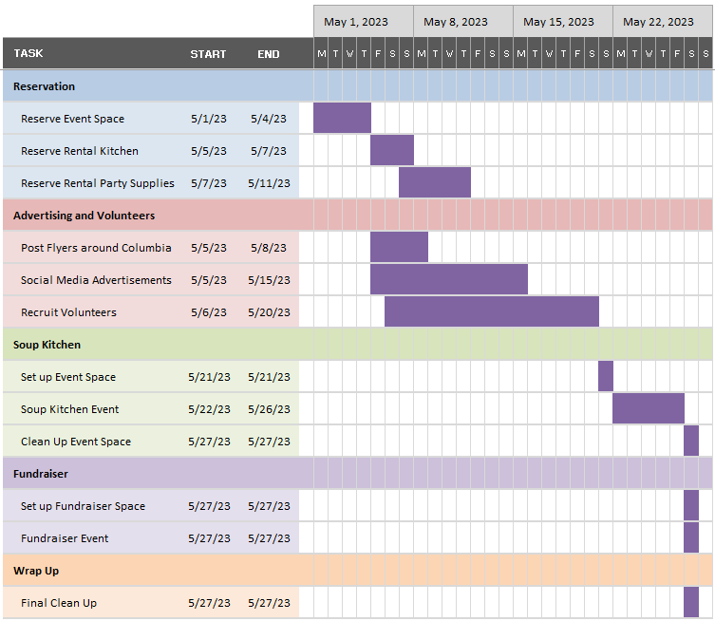

**Organizational Background**

Harvest Hope is a leading nonprofit organization dedicated to fighting food insecurity and hunger in South Carolina. Our organization has a deep commitment to improving the lives of the communities we serve by providing access to healthy and nutritious meals, addressing food insecurity, and building a future free from hunger.

With a team of highly skilled professionals, including experts in food distribution, nutrition, and community outreach, Harvest Hope has established itself as the largest food bank in South Carolina, providing over 20 million meals on average to those in need across the Midlands, Pee Dee, and Upstate regions. The organization's work is essential, given that 1 in 9 South Carolinians struggle with hunger, making it a significant public health concern.

Harvest Hope has earned numerous accolades for its contributions to the community, including organizing large-scale food bank events such as the Thanksgiving meal program, which fed over 4,000 individuals in need last year. The organization's successes reflect its commitment to serving the community and building a more equitable society.

To continue our mission of fighting hunger and food insecurity, Harvest Hope is seeking funding from General Mills to set up a week-long food bank event and fundraiser that will provide nutritious meals to those who might otherwise go without them. With General Mills' support, Harvest Hope will be able to make a significant impact in the fight against hunger and food insecurity in Columbia and the surrounding areas and help build a healthier, more resilient community for all.

**Conclusion**

Thank you for considering our grant proposal to support Harvest Hope's week-long food bank event in Columbia, South Carolina. We are excited about the potential impact of this event and appreciate your attention to this matter. Your support is vital to making this event a success and helping us eliminate hunger in our community.

To ensure a successful event, we kindly request that you respond to our proposal by May 1st, 2023, to provide sufficient time to organize and prepare. Our organization is seeking a grant of $27,500 from General Mills to cover expenses related to rent, kitchen rental, flyers, and other associated costs, allowing us to provide nutritious meals to individuals in need while raising awareness about food insecurity.

We would appreciate it if General Mills could provide the grant funds by May 10th, 2023, to allow us to allocate resources, purchase supplies, and finalize preparations for the event. You can send the funds through our organization's website or by mailing a check or money order to our address.

The event is scheduled to take place from May 21st to May 27th, 2023 at 800 Gervais St., Columbia, S.C. We look forward to making a meaningful impact in the community and working towards our goal of eliminating hunger.

Please do not hesitate to contact us if you have any further questions or need additional information. Thank you again for your consideration, and we hope to have your support in making this event a success.

**References**

“About Harvest Hope.” *About | Harvest Hope*, <https://www.harvesthope.org/about#:~:text=Our%20mission%20is%20to%20eliminate,700%2C000%20people%20in%20South%20Carolina>.

Hill, Lauren, and Catlin Nchako. “A Closer Look at Who Benefits from SNAP:

State-by-State Fact Sheets.” *Center on Budget and Policy Priorities*, Center on Budget and Policy Priorities, 13 Feb. 2023, <https://www.cbpp.org/research/food-assistance/a-closer-look-at-who-benefits-from-snap-state-by-state-fact-sheets#South_Carolina>.

“Hunger in South Carolina.” *Feeding America*, <https://www.feedingamerica.org/hunger-in-america/south-carolina>.

Junction 800. <https://www.junction800.com/wp-content/uploads/2021/09/Junction800.pdf>, *Junction 800 Rental Rates*.

“The National School Lunch Program (NSLP).” *Feeding America*, <https://www.feedingamerica.org/take-action/advocate/federal-hunger-relief-programs/national-school-lunch-program#:~:text=Low%2Dincome%20children%20are%20eligible,qualify%20for%20reduced%2Dprice%20meals>.

“National School Lunch Program.” *South Carolina Department of Education*, <https://ed.sc.gov/districts-schools/health-and-nutrition/meal-programs/national-school-lunch-program/>.

October 11, 2022. “Top 10 Hungriest States in the U.S.” *Friends Committee On National Legislation*, <https://www.fcnl.org/updates/2022-10/top-10-hungriest-states-us>.

October 11, 2022. “Top 10 Poorest States in the U.S.” *Friends Committee On National Legislation*, <https://www.fcnl.org/updates/2022-10/top-10-poorest-states-us>.

Tabone, Author: Eleanor. “Local Food Pantries Seeing More Families Seeking Help.” *Wltx.com*, 17 June 2022, <https://www.wltx.com/article/news/local/midlands-food-pantries-inrease-in-need-columbia-sc/101-a8acb9bc-48be-4fdd-9e74-6dfb906d990e>.

“What Is Food Insecurity?” *Feeding America*, <https://www.feedingamerica.org/hunger-in-america/food-insecurity?s_src=W234REFER&s_referrer=https%3A%2F%2Fmap.feedingamerica.org%2F&s_channel=https%3A%2F%2Fmap.feedingamerica.org%2F&s_subsrc=https%3A%2F%2Fwww.feedingamerica.org%2Fhunger-in-america%3F_ga%3D2.15800438.1357369662.1681671666-1213349443.1681412258>.